Question:
1. Develop a Python program to create a line plot of the monthly temperature data.
2. Develop a Python program to create a scatter plot of the monthly rainfall data.

Program:

import matplotlib.pyplot as plt

rainfall = [80, 120, 150, 90, 40, 20, 10]
months = ["Jan","Feb","Mar","Apr","May","Jun","Jul"]

plt.scatter(months, rainfall)
plt.xlabel("Months")
plt.ylabel("Rainfall")
plt.title("Monthly Rainfall")
plt.show()

Output:

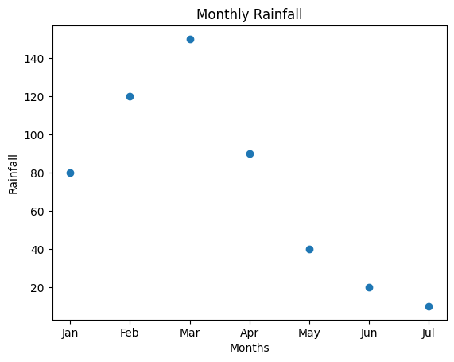
Program:

import matplotlib.pyplot as plt
sales=[10,20,15,25,30]
days=[1,2,3,4,5]
plt.scatter(sales,days)
plt.xlabel("Sales")

plt.ylabel("Days")
plt.title("Sales in a store")
plt.show()

Output:

